Backend Development
Topic: Contact Manager
Name: I.Lubna
C.Dayan Begam
S.Loga Rubika
S.Nandhika
Register Number: 212402943
212402919
212402942
212402954
I.Lubna NM id: 52DF363A11EAC5B95A34FB215E7EEC98
C.Dayan Begam NM id: 57E2E9AE21093D5BE054A96F0B9739A3
S.Loga Rubika NM id: 6D8BB4018C0BE36B0EB49A0835680DD6
S.Nandhika NM id: 746356AFD166848B41844B3CE93D5C01

TABLE OF CONTENTS
Date | Contents | Page.No
 | Introduction
 | Project Overview
 | Architecture
 | Setup instructions
 | Component documentation
 | Stage Management
 | User Interface
 | Styling
 | Testing
 | Screenshots and Demo
 | Known issues
 | Future Enhancements

Introduction
In today's digital world, managing contact information efficiently is very important for individuals as well as organizations. A Contact Management System is a software application that helps users store, organize, retrieve, and manage contact details in a systematic way. Instead of maintaining contacts manually in notebooks or spreadsheets, a digital system provides better organization, faster access, and improved data management.
The backend of a Contact Management System plays a crucial role in handling all data processing and communication between the user interface and the database. Backend development is responsible for storing contact details, validating data, processing user requests, and ensuring that information is securely retrieved whenever needed.
This project focuses on the development of a backend system for managing contacts. The system allows users to add new contacts, update existing contact information, delete contacts that are no longer required, and view stored contact details. The backend ensures that all operations are performed accurately and efficiently.
The purpose of this backend system is to provide a reliable platform that can manage contact information effectively while ensuring data integrity, security, and smooth interaction between system components.

Project Overview
The Contact Management System is designed to help users organize and manage contact details in a centralized database. This system allows users to store important information such as names, phone numbers, email addresses, and other related details.
The main objective of the project is to create a backend system that supports all the core functionalities required for managing contacts. The backend processes requests received from the user interface or API testing tools and performs the required database operations.
The system provides the following major functionalities:
• Adding new contacts to the database
• Viewing a list of all saved contacts
• Updating existing contact information
• Deleting unwanted contacts from the system
• Searching for specific contacts
By implementing these features, the system helps users maintain a well-organized contact database. It also reduces the chances of losing important contact information and allows users to access their data quickly whenever required.
The backend ensures that all operations are handled securely and efficiently while maintaining proper communication between the application components.

Architecture
The architecture of the Contact Management System backend follows a structured approach to ensure better performance, scalability, and maintainability. The system is designed using a layered architecture where each layer performs a specific function.
Presentation Layer
The presentation layer is responsible for interacting with the user interface. Although the backend does not directly handle visual elements, it receives requests from the frontend application or API testing tools such as Postman. This layer sends user requests to the backend server.
Application Layer
The application layer contains the core logic of the system. It processes incoming requests, validates the input data, and performs the necessary operations. This layer also ensures that proper business rules are followed while managing contact data.
Data Layer
The data layer manages the storage of information in the database. It is responsible for inserting, retrieving, updating, and deleting contact details. The database stores structured information that can be accessed by the backend whenever required.
The communication between these layers ensures smooth functioning of the system. When a user sends a request, it is processed by the backend logic and the appropriate response is returned after interacting with the database.
This architecture helps maintain a clear separation of responsibilities, making the system easier to manage and expand in the future.

Setup Instructions
To successfully run the backend Contact Management System, certain setup procedures must be followed. These steps ensure that the required software tools and dependencies are properly installed and configured.
The first step is installing the necessary software tools required for backend development. This includes a runtime environment such as Node.js, a package manager such as npm, and a database management system such as MongoDB or MySQL. These tools help in executing the backend application and managing stored data.
After installing the required tools, the project files must be downloaded or cloned from the project repository. This allows the developer to access the source files and project structure.
Once the project files are available, all necessary dependencies must be installed. These dependencies include libraries and frameworks that support backend operations such as server management, database communication, and request handling.
The next step involves configuring the database connection. This includes specifying database details such as the database name, connection address, and authentication information if required.
After completing the configuration process, the backend server can be started. Once the server starts successfully, it begins listening for incoming requests and processes them accordingly.
The system can then be tested using API testing tools to ensure that all backend functionalities are working correctly.

Component document
The backend Contact Management System consists of several important components that work together to perform different tasks within the application. Each component plays a specific role in ensuring the smooth operation of the system.
Server
The server is the central component of the backend application. It receives incoming requests from users or applications and sends back the appropriate responses. The server also manages communication between different parts of the system.
Routes
Routes define the various endpoints through which users can interact with the system. Each route represents a specific operation such as adding a new contact, retrieving contact information, updating existing details, or deleting contacts.
Routes help organize how different types of requests are handled by the system.
Controllers
Controllers contain the logic responsible for processing user requests. They receive input data, perform necessary validations, and execute the required operations on the database. After processing the request, controllers send the response back to the user.
Database Model
The database model defines the structure of the data stored in the system. It specifies the fields required for storing contact information such as name, phone number, email address, and address.
By defining a clear structure for data storage, the system ensures consistency and reliability while managing contact records.

Stage Management
State management in backend systems refers to the way data is handled during the execution of requests. Since backend applications process multiple user requests, it is important to maintain proper control over how data is stored and retrieved.
In the Contact Management System, state management is mainly handled through the database. Each contact record stored in the database represents the current state of that particular contact.
Whenever a user performs an action such as adding, updating, or deleting a contact, the system updates the database accordingly. This ensures that the most recent and accurate information is always available.
The backend processes each request independently while retrieving the necessary data from the database. This approach helps maintain consistency and ensures that the application can handle multiple requests efficiently.

User Interface
Although this project focuses on backend development, the system is designed to interact with a user interface or client application. The user interface provides a way for users to send requests to the backend server and receive responses.
Users can perform various operations through the interface, such as adding new contacts, viewing stored contacts, editing contact information, or deleting unwanted entries. These actions are converted into requests that are sent to the backend system.
During development and testing, tools such as Postman can also act as the user interface. These tools allow developers to send requests directly to the backend APIs and verify whether the system is functioning correctly.
The backend processes these requests and returns the requested data in a structured format that can be easily displayed by the user interface.

Styling
Styling is mainly related to the visual design of the frontend interface. However, the backend plays an important role in ensuring that the data returned to the frontend is properly structured and formatted.
The backend sends responses in a standardized data format, typically JSON (JavaScript Object Notation). This format allows the frontend application to easily interpret and display the data to users.
By maintaining consistent response formatting, the backend ensures that the frontend application can present contact information clearly and efficiently.
Proper formatting of responses also improves communication between different system components and helps maintain the overall reliability of the application.

Testing
Testing is an essential part of backend development. It ensures that the system functions correctly and that all features operate as expected.
The Contact Management System backend is tested by sending different types of requests to the API endpoints. These tests verify whether the system correctly handles operations such as adding, retrieving, updating, and deleting contacts.
Testing also helps identify potential errors, bugs, or performance issues within the application. By fixing these issues during development, the overall reliability of the system can be improved.
Various testing tools can be used to evaluate the performance and functionality of the backend system. Through regular testing, developers can ensure that the application remains stable and capable of handling user requests efficiently.

Screenshots and Demo
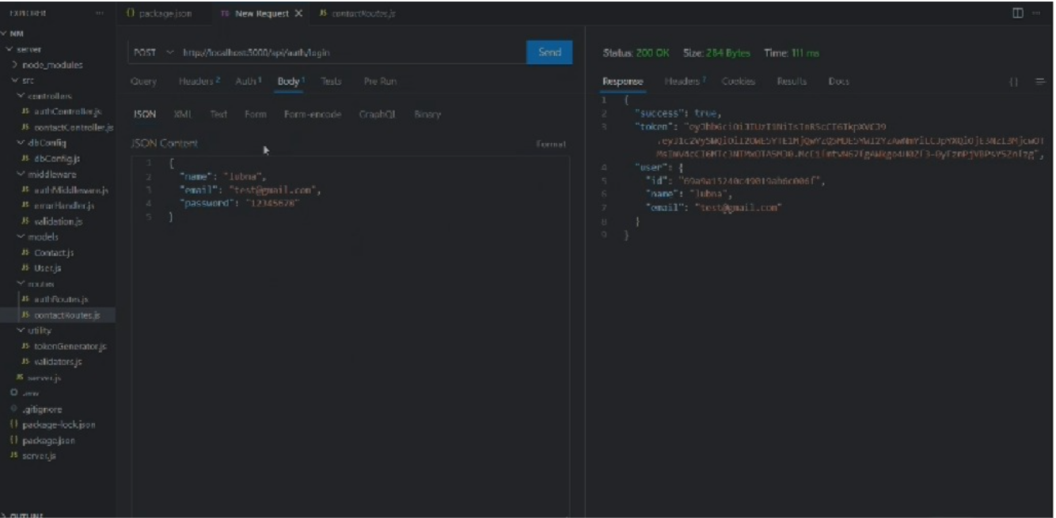
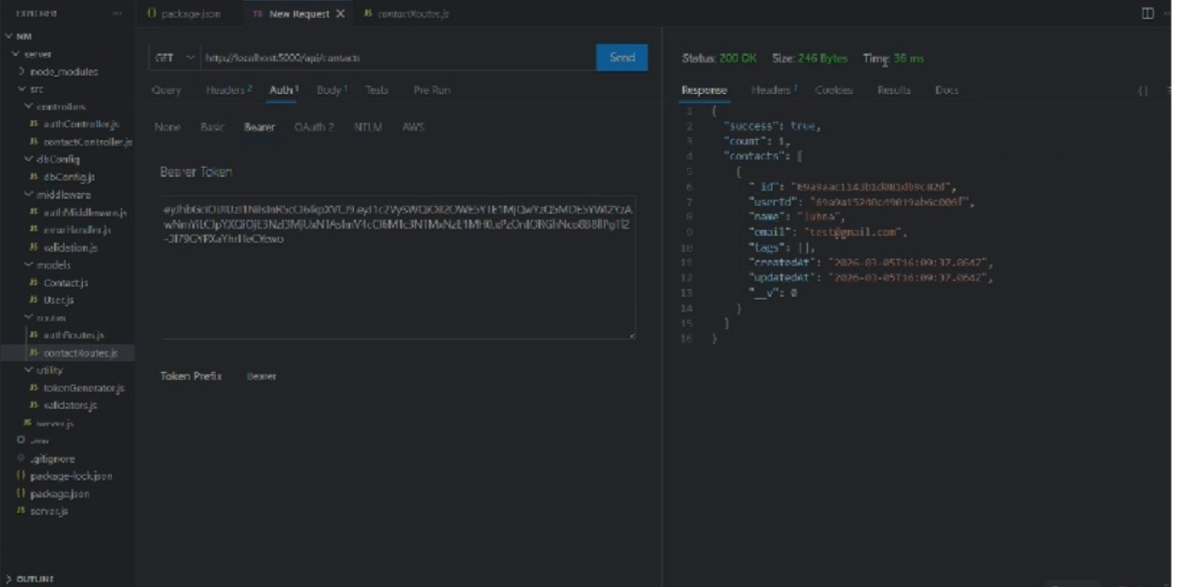
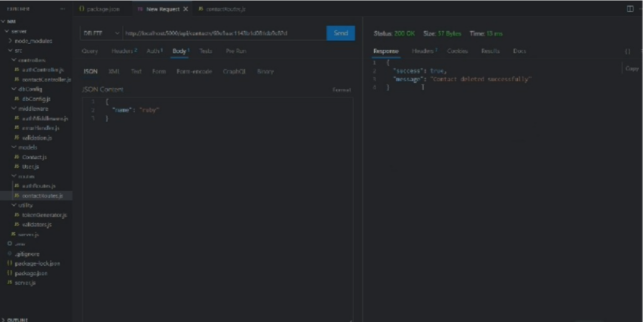
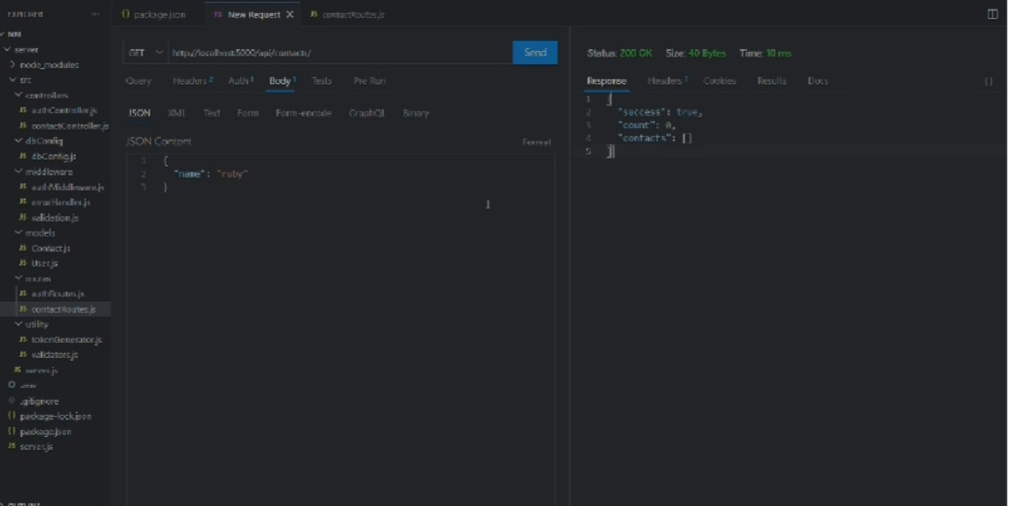
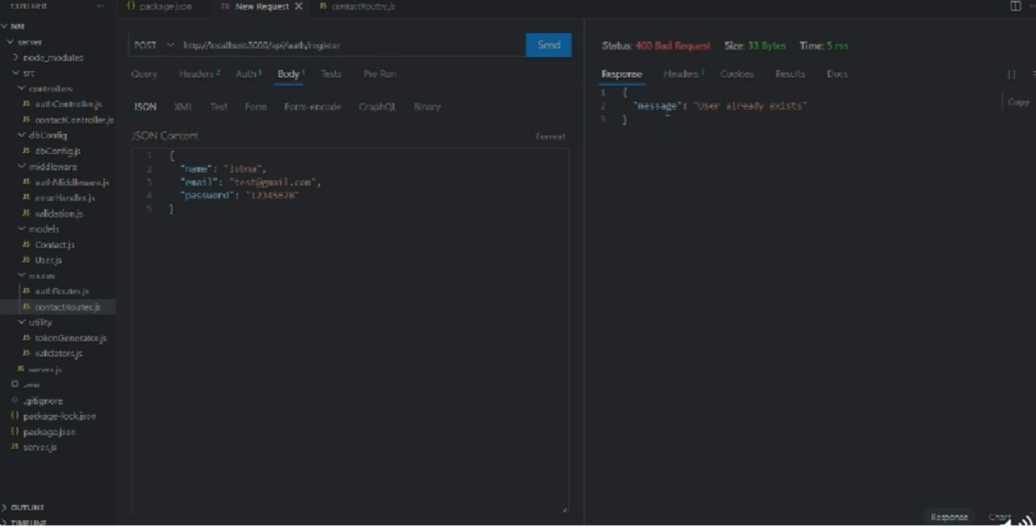

Demo Video.

The main objective of this project is to develop a backend system that helps manage contact information efficiently. The system allows users to add, view, update, and delete contact details such as name, phone number, and email address.
The backend processes user requests, communicates with the database, and returns the required information. It ensures that contact data is stored in a structured and organized way.
Through this system, users can easily manage their contacts using API requests and database operations.
Link for the demo video
https://drive.google.com/file/d/1gxv-BnydoTS9_uIZDDdfruIB04kiDC_k/view?usp=sharing

Known Issues
Like many software applications, the Contact Management System may experience certain limitations or issues during its operation. These issues may arise due to system constraints, incomplete features, or unexpected errors during data processing.
One possible issue is the lack of advanced authentication mechanisms. Without proper authentication, unauthorized users may gain access to the system if security measures are not implemented.
Another limitation may involve handling extremely large datasets. If the database grows significantly, the system may require optimization techniques to maintain performance.
In some cases, validation errors may occur when incorrect or incomplete contact information is submitted. Proper error handling mechanisms must be implemented to address such situations.
Identifying these issues helps developers improve the system and ensure that it performs reliably under different conditions.

Future Enhancements
The Contact Management System can be further improved by adding several advanced features and enhancements. These improvements can increase the functionality, usability, and security of the application.
One possible enhancement is the implementation of user authentication and authorization. This would allow only authorized users to access and manage contact information.
Another improvement could involve adding search and filtering capabilities. This would allow users to quickly find specific contacts based on different criteria such as name, phone number, or email address.
Integration with cloud storage services could also be considered to allow users to access their contacts from multiple devices.
Additionally, implementing data backup and recovery mechanisms would help protect important contact information from accidental loss.
Future development could also include the addition of analytics features that provide insights into contact usage and management.
These enhancements would make the Contact Management System more powerful, secure, and user-friendly.

